Supplementary Material

Frequency-domain diagonal extension imaging

Shan Jianga,b,c, Meiling Guana, Jiamin Wud, Guocheng Fange, Xinzhu Xua, Dayong Jinb,e, Zhen Liue, Kebin Shif, Fan Baig, Shu Wangh, and Peng Xia,b*

aPeking University, College of Engineering, Department of Biomedical Engineering, Beijing 100871, China

bSouth University of Science and Technology China, Department of Biomedical Engineering, Guangdong 510855, China

cBeijing Institute of Collaborative Innovation (BICI), Beijing, China

dTsinghua University, Department of Automation, Beijing 100084, China

eUniversity of Technology Sydney, Faculty of Science, Institute for Biomedical Materials & Devices (IBMD), Ultimo, NSW 2007, Australia

fPeking University, School of Physics, Beijing 100871, China

gPeking University, School of Life Sciences, Biodynamic Optical Imaging Center (BIOPIC), Beijing 100871, China

hPeking University People's Hospital Breast Center, Beijing 100044, China

[*xipeng@pku.edu.cn](mailto:*xipeng@pku.edu.cn)

**Abstract**

In this supplement, the details about the FDDE lensfree microscopy are presented. The workflow of FDDE is illustrated with graphs. The simulation of FDDE lensfree microscopy with different amounts of raw images is presented, and the result show 3 phases of imaging angles are sufficient to generate an isotropic super-resolution image. The experiment of FDDE lens-based photograph is presented with different lens and CMOS chip other than in the primary article.The methods and the materials of the experiments are presented.

**Diagram of the frequency-domain diagonal extension (FDDE) image processing**

In FDDE, the image processing procedure can be illustrated as (Fig S1):

1. Collect the raw images at different angles in relative to the rectangular CCD or CMOS sensor;
2. FFT interpolation on the raw images with Zero-padding method more than 2 times. In Lensfree microscopy, the raw image should be reconstructed based on ref [31];
3. Rotate the raw images to the same direction, then a registration algorithm is utilized to correct the position of each image [31];
4. Perform FFT to the rotated images;
5. Stitch the frequency-domain of the images by replacing the low-frequency with high-frequency regions;
6. IFFT to obtain the high-resolution image with FDDE.

Fig. S1. The diagram of FDDE super-resolution microscopy/imaging.

**Simulation of the frequency-domain diagonal extension (FDDE) with different phases**

The high-frequency components from the images of two and three phases are stitched into one image, as presented in Fig. S2 (e) and (g). Then, the merged frequency domain is transformed into the spatial domain, as presented in Fig. S2 (d) and (f).

In the Fourier domain of the combined result with two images, as presented Fig. S2 (e), two raw images with an angle difference of 45 degrees are utilized. More details can be resolved than in the case of a single image, and we can see almost three lines in more directions, as shown in Fig. S2 (d). However, the three circles are transformed into an octagon-like shape, which is attributed to the lack of high frequency components in the vacancy directions between the two raw images.

In Fig. S2 (g), the combined result with three images is presented. Even if the frequency domain is not perfectly circular, one can see from the resulting image (Fig. S2 (f)) that in every direction, the three circles can be resolved clearly. Therefore, a resolution of 0.7× pixels in every direction has been achieved when using only three raw images, corresponding to 1.4× the conventional imaging resolution. Comparing Fig. S2 (c) and (f), it is obvious that the anisotropic resolution can impede the interpretation of the microscopic image.

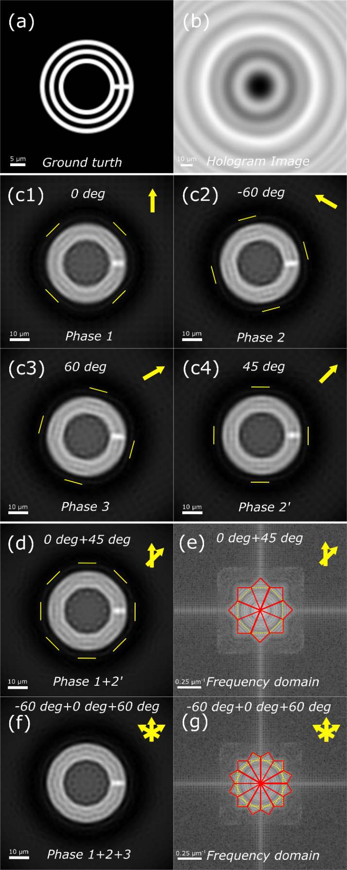

Fig. S2. The simulation of FDDE. (a) The ground truth image of three concentric circles with a line width of 1.55 μm. (b) Simulated hologram image of (a). (c) The reconstructed images with simulated hologram images for different orientations. (c1), (c2), (c3) are the raw images with an interval of π/3. (c1) and (c4) are the raw images with an interval of π/4. (e) and (g) are the high-frequency components from the images of two and three phases are stitched into one image. (d) and (f) The spatial domain of the merged frequency domain in (e) and (g). The short lines marked in (c) and (d) are the direction that the three circles could be resolved.

**Application of the frequency-domain diagonal extension (FDDE) in photography**

We have also performed the frequency-domain diagonal extension (FDDE) to photography. A webcam lens was used together with the CMOS chip (Micron, MT9P031) for imaging. Here, we have imaged the USAF-1951 resolution target. And the distance between the sample and the camera is 30 cm. The raw images with different imaging angles are presented in Fig. S3 (a) and (b). Then, the raw images are interpolated 4 times with FFT zero-padding method, as presented in Fig. S3 (c) and (d). The resolution in Fig. S3 (c) and (d) is 111.36 and 88.39 micrometer, which are corresponding to group 2 line 2 and line 4. The resolution in the diagonal direction is ~1.3 times higher than the horizontal and vertical direction, which is consistent with the principle of FDDE. This enhancement shows that the pixel size is bigger than the Nyquist sampling theory.

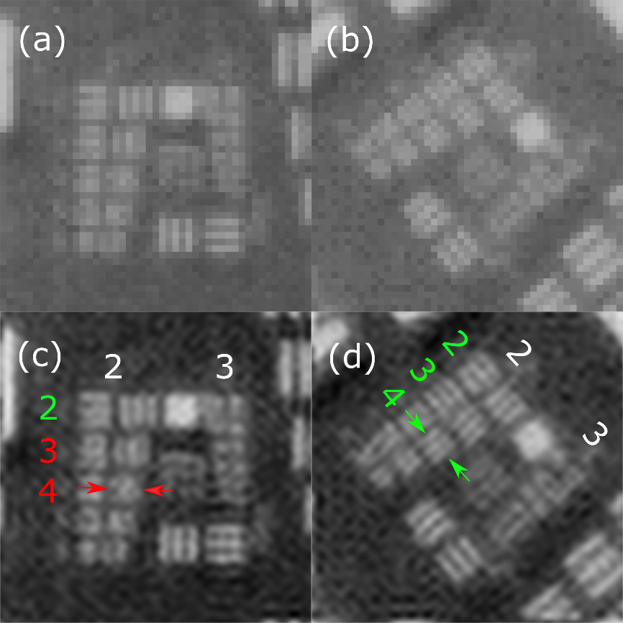

Fig. S3 The resolution enhancement of FDDE in photography. (a) and (b) are the raw images captured with conventional lens and CMOS chip under different angles. (c) and (d) are the interpolated image of (a) and (b). The group 2 line 2 and line 4 are the narrowest line resolved in (c) and (d), respectively.

**Lensfree microscope setup**

The incoherent light source of this lensfree microscope consists of a white-light light-emitting diode (LED), a 610 nm-centered band-pass filter, a collective lens, and a visible-light transmitting multimode optical fiber (Connet, MMJ-S105). The emitted light of the white LED is filtered by the 610 nm filter, which has a spectral bandwidth of 15 nm. Then, the 610 nm light is collected and coupled into the optical fiber, and the light is directed to illuminate the sample through the optical fiber. The outlet of the optical fiber is located 10 cm above a monochrome CMOS chip (Micron MT9P031), which has a pixel size of 2.2 μm. The CMOS chip is mounted on an x-y plane rotation stage. The distance between the resolution target and the CMOS chip is ~0.4 mm, attributed to the protection layer on the surface of the chip. The holographic image reconstruction algorithm is coded based on the algorithm published in Ref. [30].

**Lens-based photography setup**

A webcam lens was used together with a CMOS chip (Micron MT9P031) for imaging.

**FDDE data processing**

The imaging process of FDDE is to acquire raw images with different directions of the CCD or CMOS by the conventional method such as Lensfree microscopy and photography. The raw images with different directions are rotated to the same orientation in post-processing. Then the Fourier domain of the raw images are combined into one and transformed back into the spatial domain, to get the FDDE image. The reconstruction for lensfree microscopy and the frequency combination were coded with MATLAB R2017a (MathWorks Inc.). The blood smear and the mouse skin histology sample were purchased from Suzhou Shenying Inc. The USAF 1951 resolution target is a commercial product (Edmund Optics, DA101E 64862), and the ISO 12233 resolution target is printed on an A4 paper with a conventional laser printer.